2.6.12 Medication Dispensing and Batch Recording
Figure 12: Functional view for medication dispensing and batch recording

2.6.13 Automatic Stock Reduction
Figure 13: Functional view for automatic stock reduction

2.6.14 Daily Dispensing Report
Figure 14: Functional view for daily dispensing report

2.6.15 Medicine Inventory and Availability
Figure 15: Functional view for medicine inventory and availability

2.6.16 Low Stock Expiry and Inventory Reports
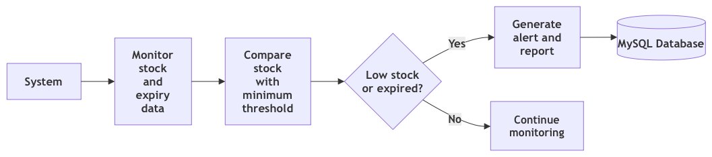
Figure 16: Functional view for low stock expiry and inventory reports

2.6.17 Email and SMS Notification Gateway
Figure 17: Functional view for email and sms notification gateway

